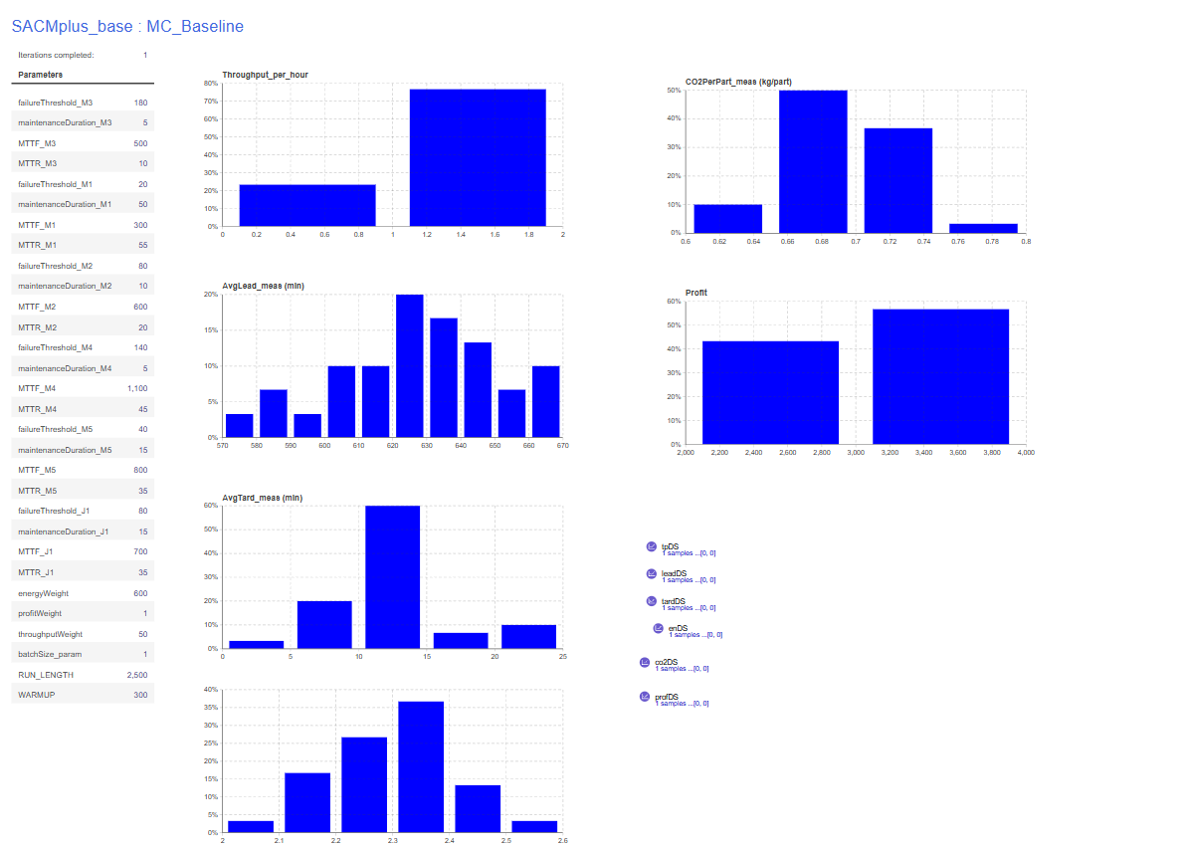
Console:
Warm-up reached. measuring=true
measuring=true leadSamples=47 tardSamples=47
Warm-up reached. measuring=true
measuring=true leadSamples=47 tardSamples=47
Warm-up reached. measuring=true
measuring=true leadSamples=35 tardSamples=35
Warm-up reached. measuring=true
measuring=true leadSamples=50 tardSamples=50
Warm-up reached. measuring=true
measuring=true leadSamples=46 tardSamples=46
Warm-up reached. measuring=true
measuring=true leadSamples=41 tardSamples=41
Warm-up reached. measuring=true
measuring=true leadSamples=43 tardSamples=43
Warm-up reached. measuring=true
measuring=true leadSamples=48 tardSamples=48
Warm-up reached. measuring=true
measuring=true leadSamples=50 tardSamples=50
Warm-up reached. measuring=true
measuring=true leadSamples=36 tardSamples=36
Warm-up reached. measuring=true
measuring=true leadSamples=43 tardSamples=43
Warm-up reached. measuring=true
measuring=true leadSamples=40 tardSamples=40
Warm-up reached. measuring=true
measuring=true leadSamples=44 tardSamples=44
Warm-up reached. measuring=true
measuring=true leadSamples=33 tardSamples=33
Warm-up reached. measuring=true
measuring=true leadSamples=57 tardSamples=57
Warm-up reached. measuring=true
measuring=true leadSamples=31 tardSamples=31
Warm-up reached. measuring=true
measuring=true leadSamples=50 tardSamples=50
Warm-up reached. measuring=true
measuring=true leadSamples=51 tardSamples=51
Warm-up reached. measuring=true
measuring=true leadSamples=34 tardSamples=34
Warm-up reached. measuring=true
measuring=true leadSamples=52 tardSamples=52
Warm-up reached. measuring=true
measuring=true leadSamples=47 tardSamples=47
Warm-up reached. measuring=true
measuring=true leadSamples=40 tardSamples=40
Warm-up reached. measuring=true
measuring=true leadSamples=48 tardSamples=48
Warm-up reached. measuring=true
measuring=true leadSamples=49 tardSamples=49
Warm-up reached. measuring=true
measuring=true leadSamples=47 tardSamples=47
Warm-up reached. measuring=true
measuring=true leadSamples=35 tardSamples=35
Warm-up reached. measuring=true
measuring=true leadSamples=33 tardSamples=33
Warm-up reached. measuring=true
measuring=true leadSamples=43 tardSamples=43
Warm-up reached. measuring=true
measuring=true leadSamples=45 tardSamples=45
Warm-up reached. measuring=true
measuring=true leadSamples=48 tardSamples=48

==== KPI NUMERIC SUMMARY (all collected replications) ====
Throughput/h | n=30 mean=1.1936 sd=0.1814 min=0.8455 max=1.5545
AvgLead | n=30 mean=627.0330 sd=23.6858 min=576.2296 max=667.5633
AvgTard | n=30 mean=12.0921 sd=4.0502 min=4.8525 max=21.9905
Energy/part | n=30 mean=2.3008 sd=0.1100 min=2.0360 max=2.5545
CO2/part | n=30 mean=0.6902 sd=0.0330 min=0.6108 max=0.7664
Profit | n=30 mean=3011.9950 sd=457.8542 min=2145.3196 max=3925.1347
==== END SUMMARY ====

